FINAL PROJECT REPORT

RECIPE MANAGEMENT

CS5600- Advanced Database System MAY 2023

Amulya Pabbu, Ajay Danam, Rohith Yalavarthi

(Student Id: 700745862,700755681,700745581, CRN:30698, Group number:4)

|  |  |  |
| --- | --- | --- |
|  | **Contents** |  |
| **Project Description** |  | **3** |
| **Document Data Model** |  | **4** |
| **MongoDB Collections** |  | **5** |
| **Functionality** |  | **10** |
| **Application - Screenshots** |  | **11** |
| **Source Codes** |  | **22** |
| **NoSQL Commands** |  | **24** |

# Project Description

The Recipe Management is a user-friendly application designed to streamline the management of recipes. It serves as a centralized platform where users can store, organize, and retrieve their favorite recipes effortlessly. The application aims to provide a convenient solution for individuals who love cooking or want to maintain a digital collection of recipes, ensuring easy access and efficient management of culinary creations.

The primary users of the Recipe Management are cooking enthusiasts, home cooks, and anyone who enjoys experimenting with new recipes. These users often face challenges in organizing and locating recipes from various sources such as cookbooks, websites, and handwritten notes. The Recipe Management caters to their information needs by providing a consolidated platform to store and manage their recipe collection. Users can conveniently search for nutritional information, specific recipes, access ingredient lists, and retrieve step-by-step instructions, thereby enhancing their overall cooking experience.

The Recipe Management allows users to input a wide range of recipe-related data. This includes the recipe title, ingredients, quantities, measurements, preparation instructions, cooking time, serving size, nutritional information and user details. Users can also add additional details such as dietary information, special instructions and personal notes. The application further supports uploading and attaching images to recipes, enhancing the visual appeal and assisting users in recognizing their favorite dishes immediately.

The database for the Recipe Management stores various pieces of information associated with each recipe. This includes the user details, recipe title(recipes), ingredients, instructions, categories, cooking time, serving size, nutritional information and attached images added by the user. Additionally, the system maintains a unique identifier for each recipe to ensure easy retrieval and manipulation of data. This enables efficient search functionality, enabling users to find recipes based on nutritional information (carbohydrate, fat, protein, etc.), specific ingredients or recipe categories.

In conclusion, the Recipe Management is an invaluable tool for cooking enthusiasts, providing a user-friendly interface to store, organize, and retrieve recipes effortlessly. By eliminating the traditional hassle of managing recipe collections, it empowers users to focus on experimenting with new dishes and discover the joy of cooking without the burden of administrative tasks.

# Document Data Model

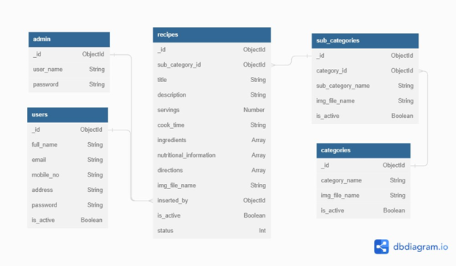

**MongoDB Collections**

admin users

categories subcategories recipes

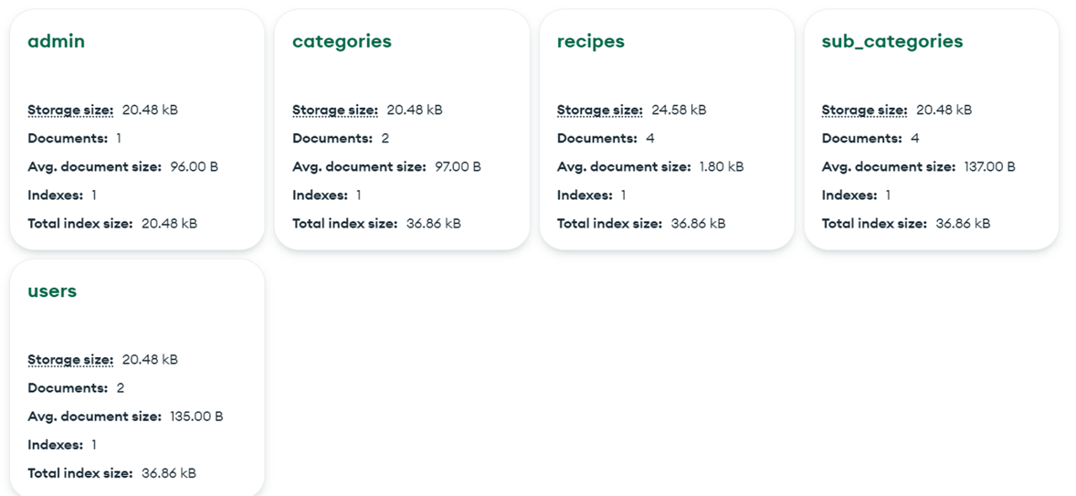

#### Admin info contains:

Id: string

Username: string

Password: string

#### Users info contains:

Id: string

Full Name: string

Email: string

Mobile: number

Password: string

Address: string

#### Categories info contains:

Id: string

Category Name: string

Image: string

Is active: boolean

#### Subcategories info contains:

Id:string

Category Id: string

Subcategory Name: string

Item Image: string

Is active: boolean

#### Recipes info contains:

Id: string

Category Id: string

Subcategory Id: string

Recipe Title: string

Servings: string

Cook time: string

Description: string

Ingredients: array

Directions: array

Nutritional Information: array

Item Image: string

Is active: boolean

#### Admin sample document

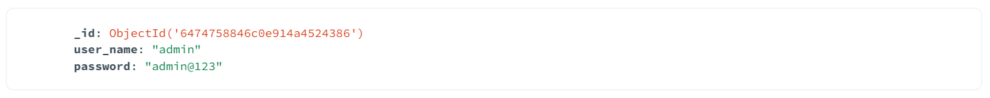

**Users sample document**

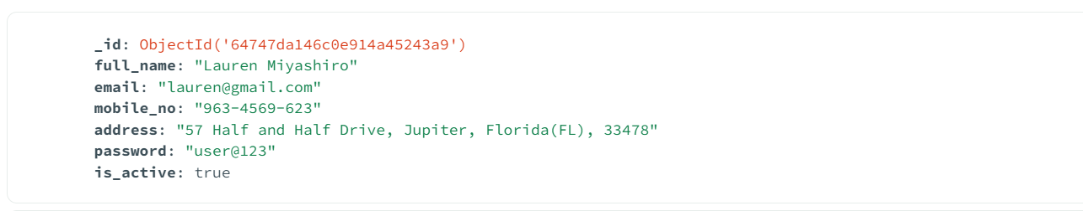

#### Categories sample documents

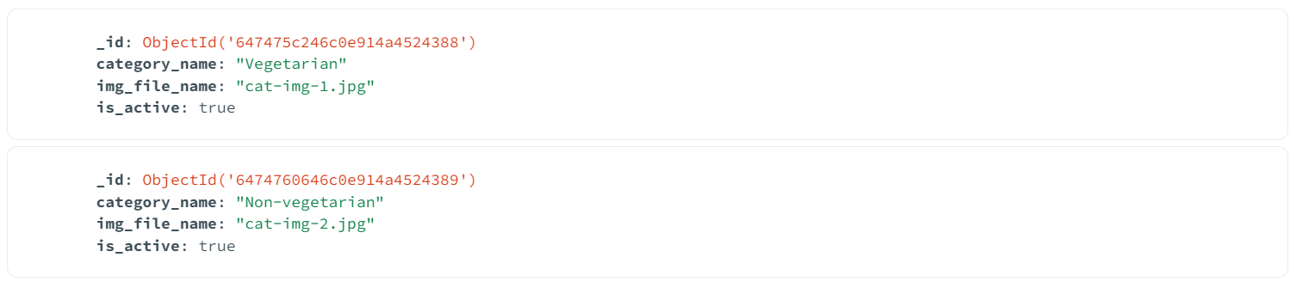

**Subcategories sample documents**

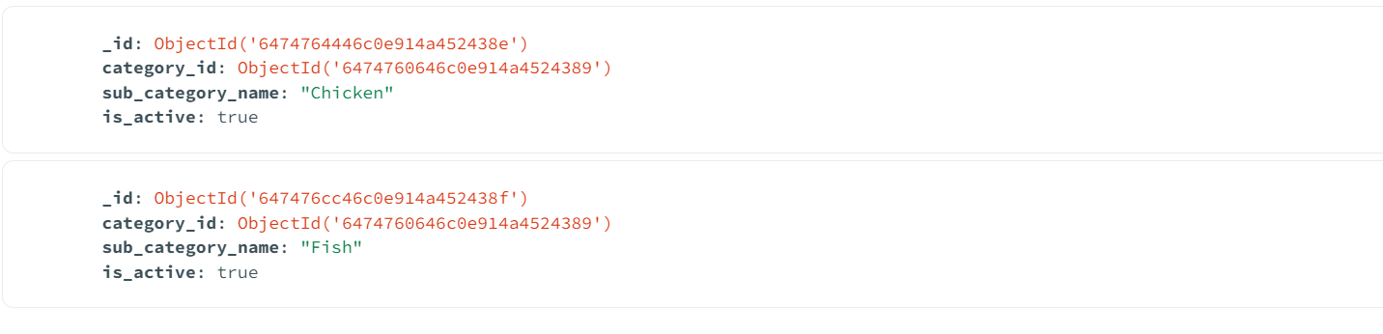

**Recipes sample documents**

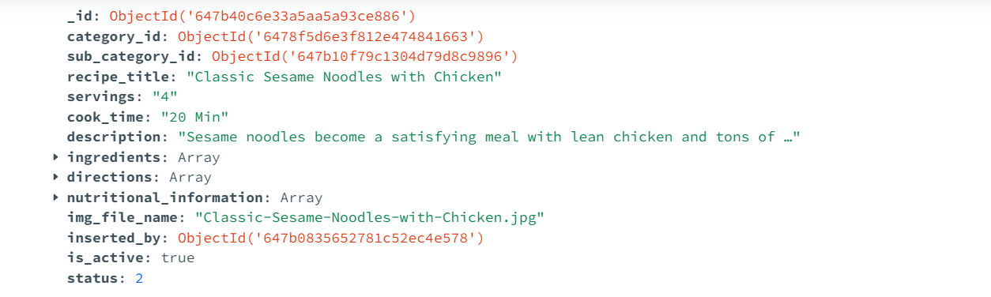

**Recipes-Ingredients sample documents**

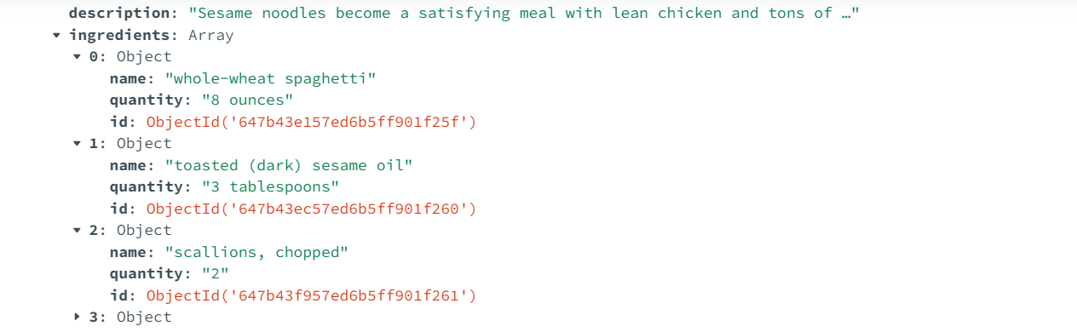

**Recipes-Nutritional Information sample documents**

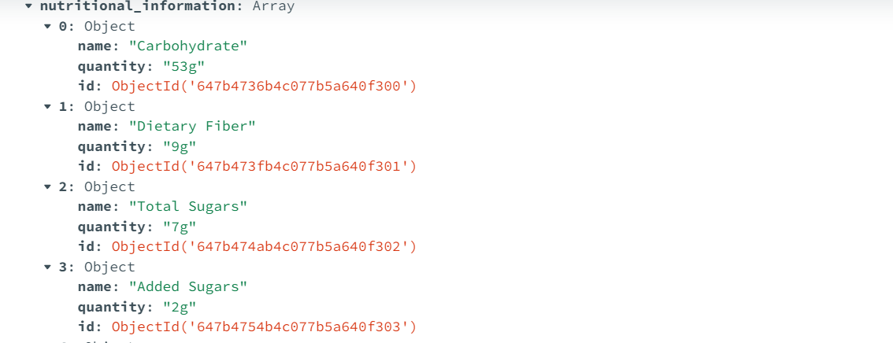

# Functionality

The Database and Web Application allows Users and Admin to complete the following functions:

Admin:

* Admin can login using his credentials.
* Admin can add, modify or delete categories.
* Admin can add, modify or delete subcategories.
* Admin can add, modify or delete recipes.
* Admin can view, approve or reject user added recipes.
* Admin can view or delete registered users.

User:

* Users can register themselves into this application by providing some basic information like full name, contact number, email, address and password.
* Users can view all available recipes in this application.
* Users can also share recipes in this application.
* Added recipe will be approved or rejected by the admin and once the recipe is approved it can be viewed by other users.
* Users can also update or delete their recipes.

The Mongo DB database document changes as the data is added and updated from front end by user or Admin.

# Application - Screenshots

### **Home page**

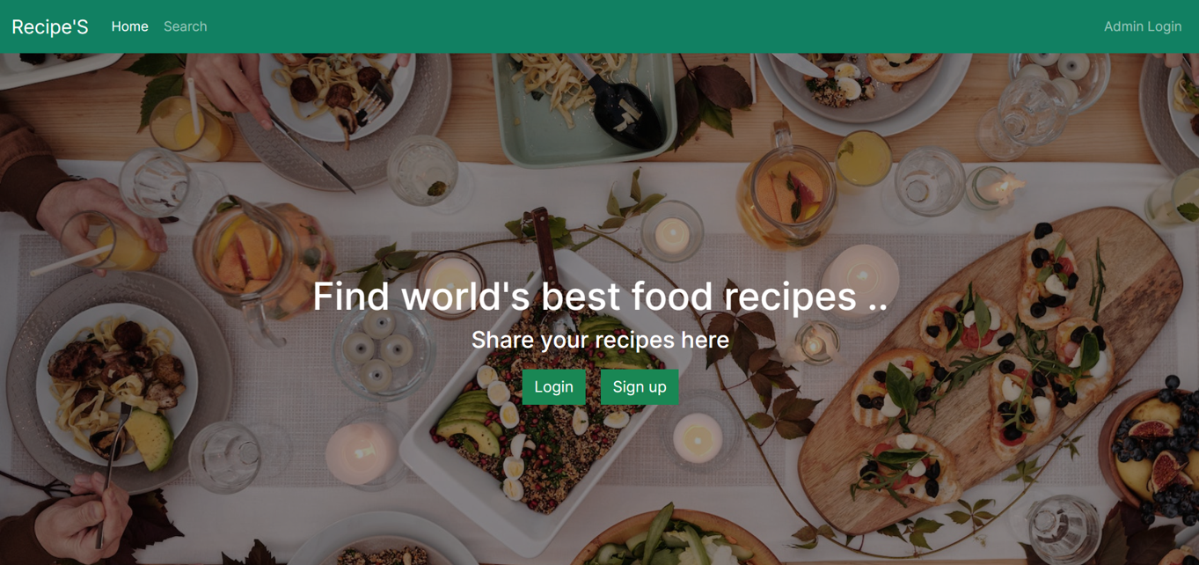

### **Categories page**

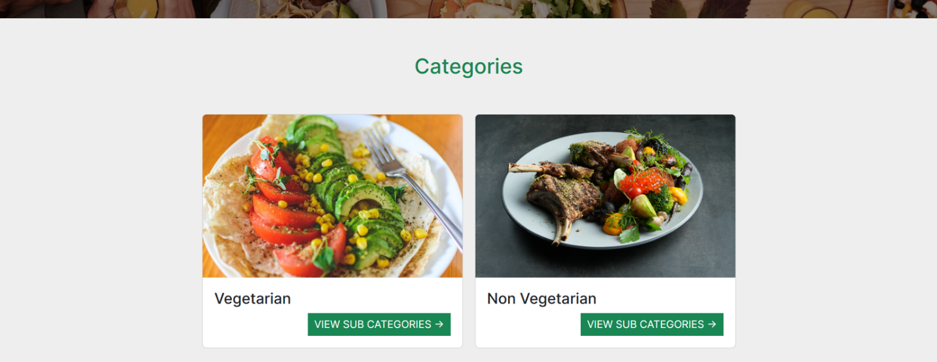

### **Recently Added Recipes page**

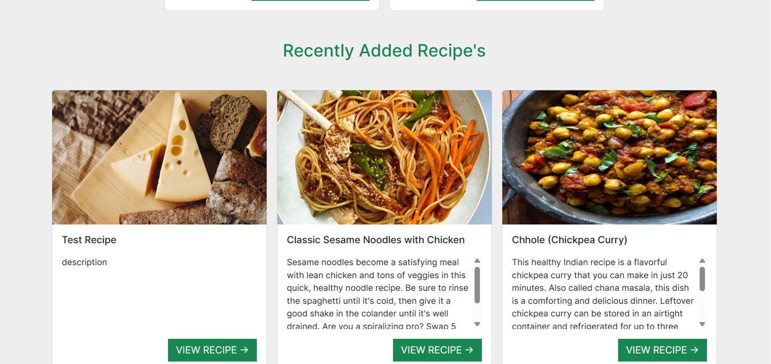

### **Vegetarian Recipes page**

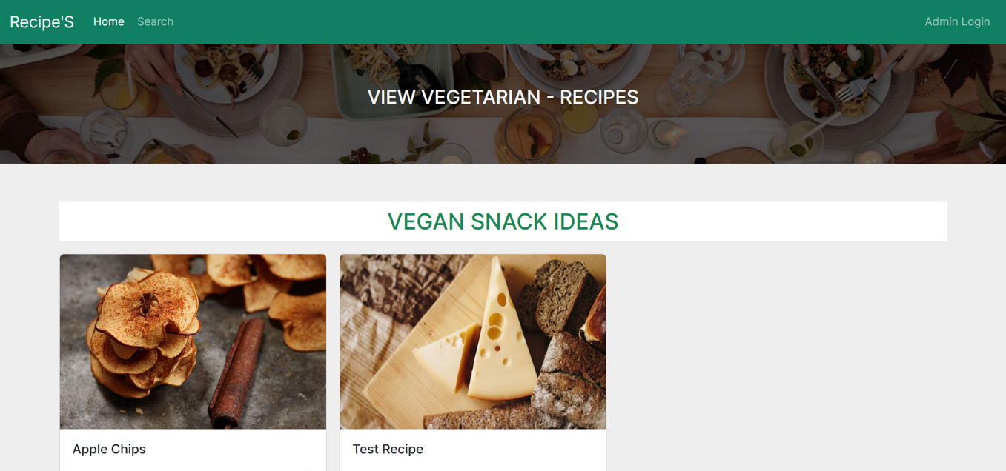

### **Recipe Details page**

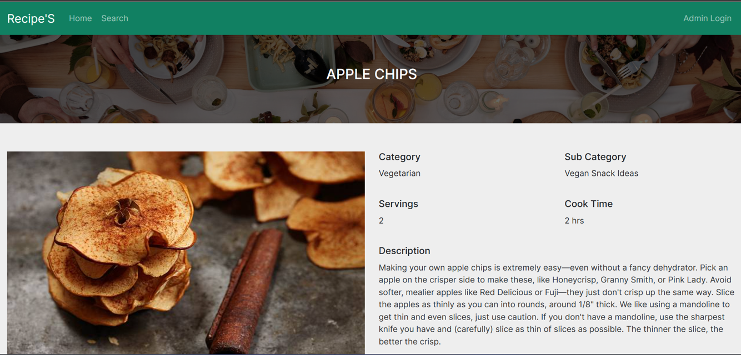

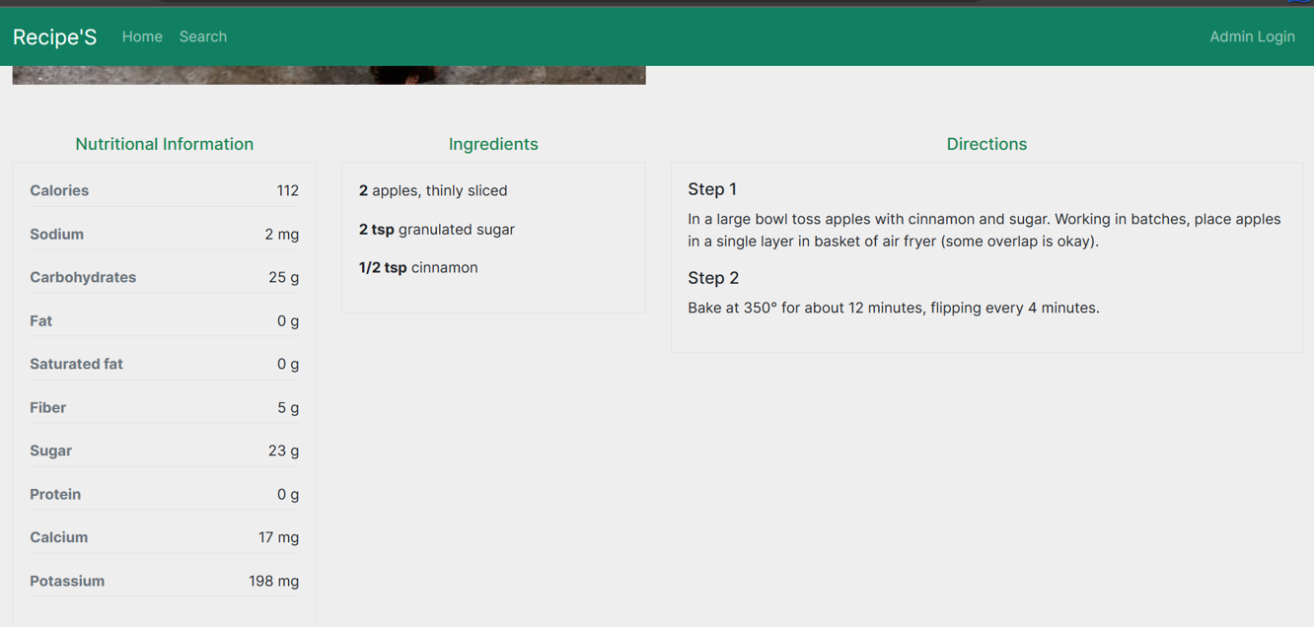

**Search page**

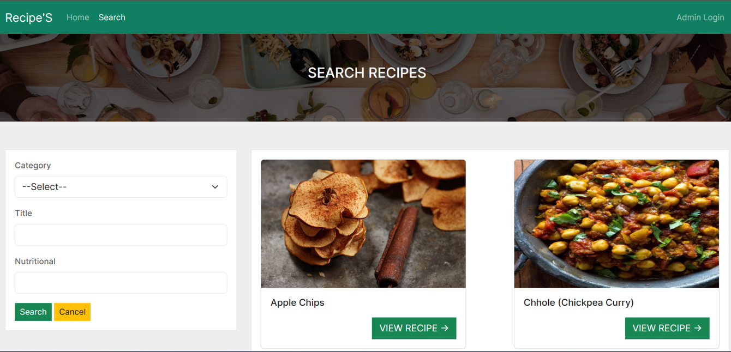

**Admin Login Page**

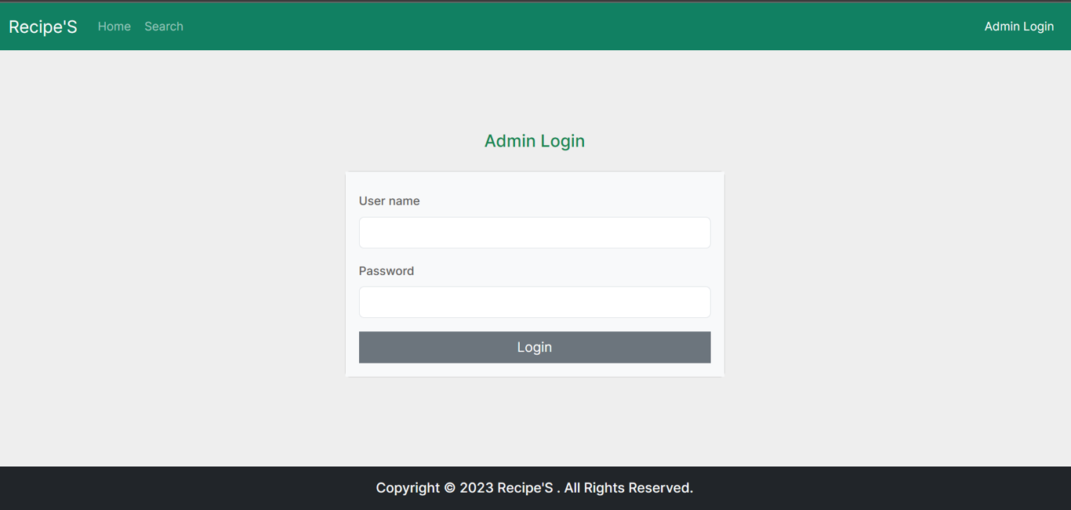

### **Admin Dashboard Page**

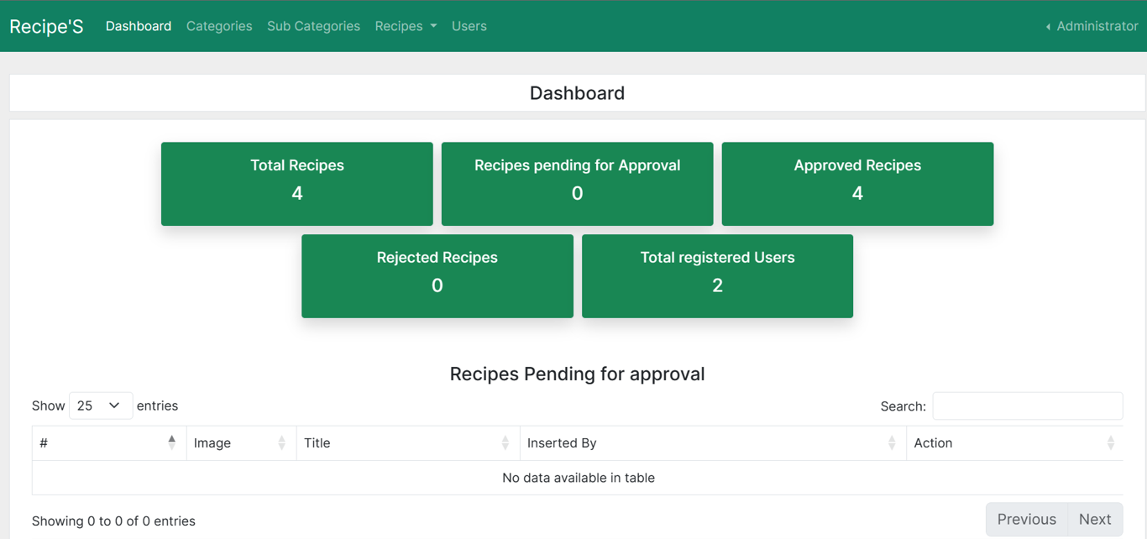

### **Admin Categories Page**

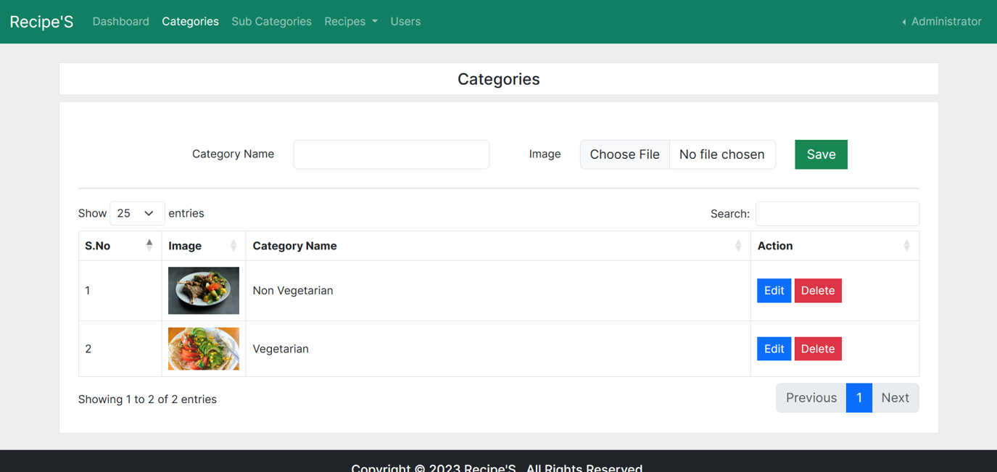

### **Admin Subcategories Page**

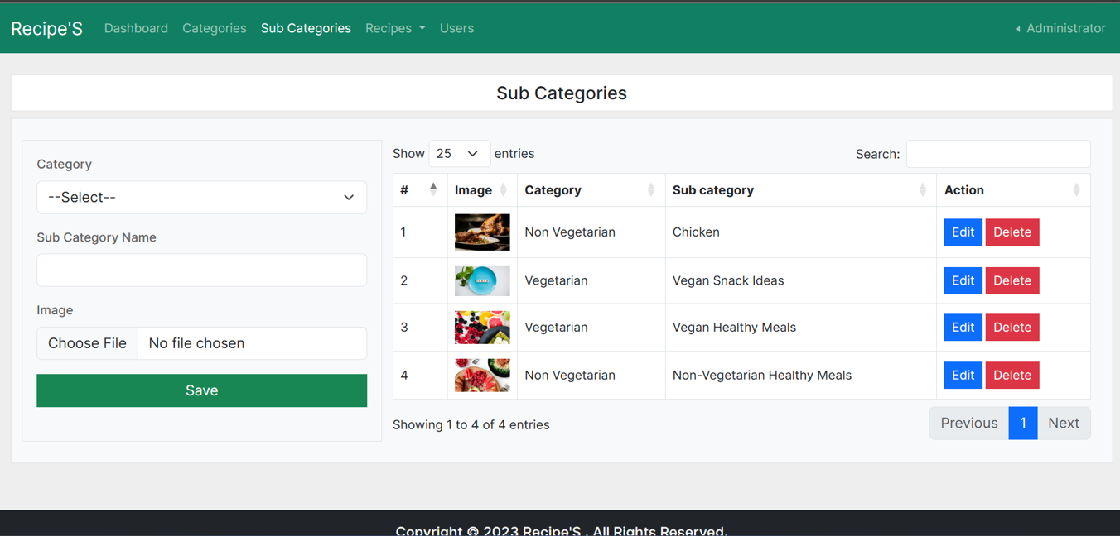

**Admin Recipes Page**

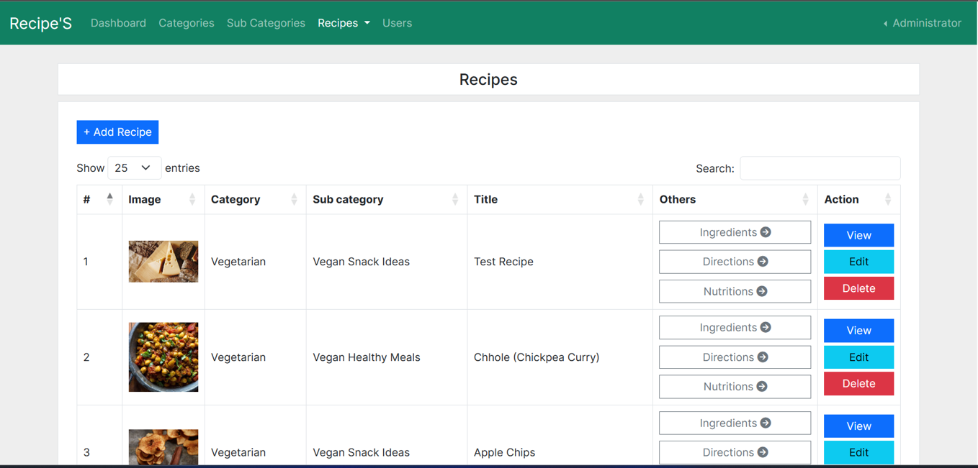

**Admin Add/Edit Recipes Page**

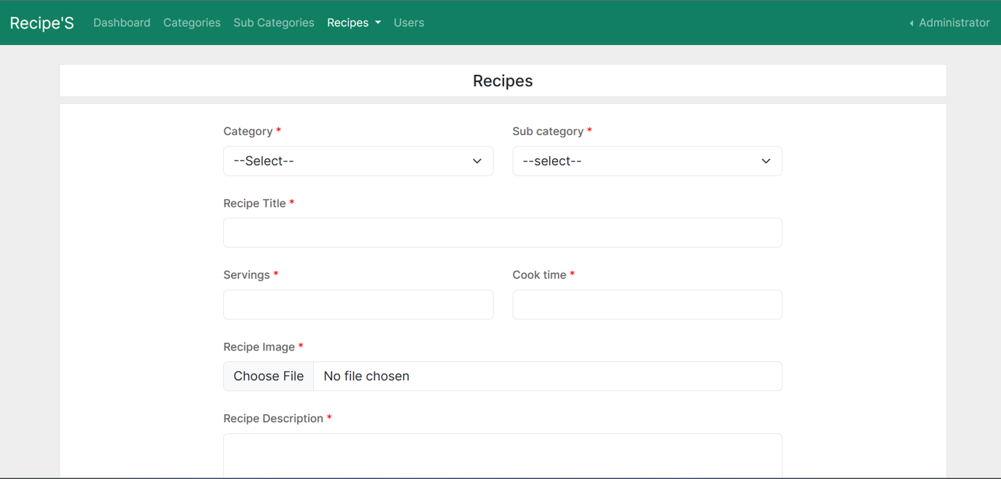

**Admin Recipe-Ingredients Page**

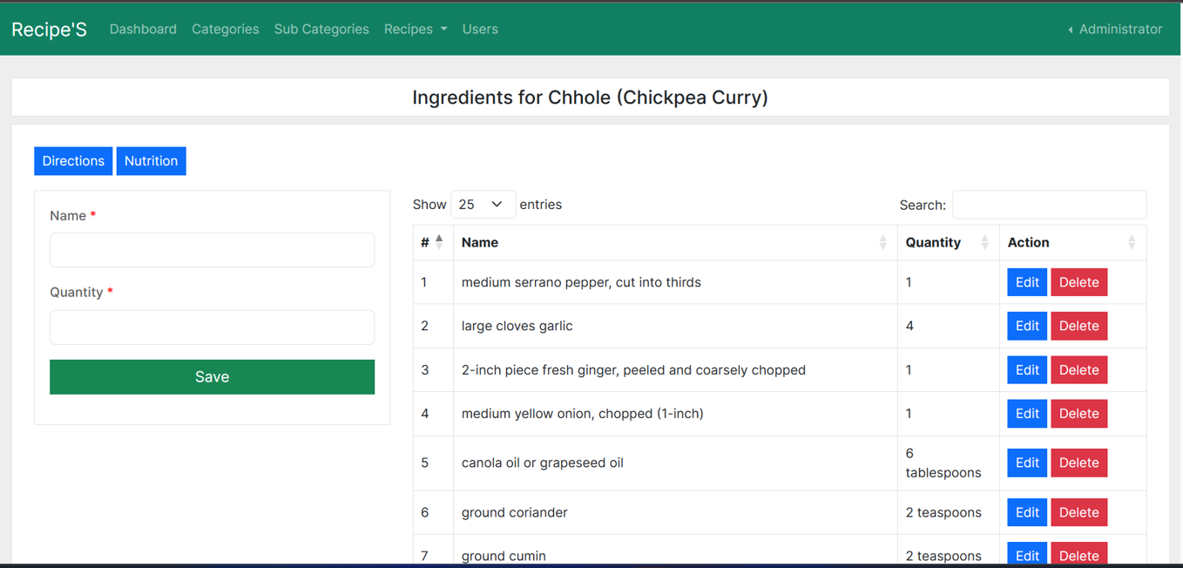

**Admin Recipe-Directions Page**

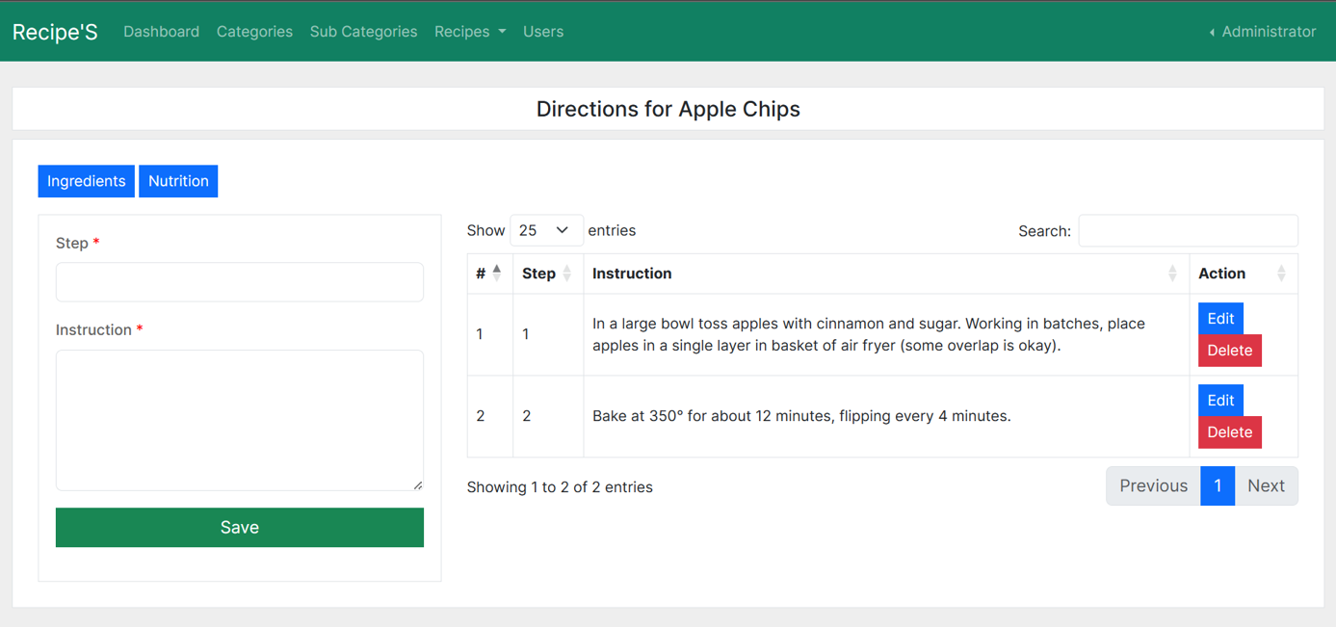

**Admin Recipe-Nutritional Information Page**

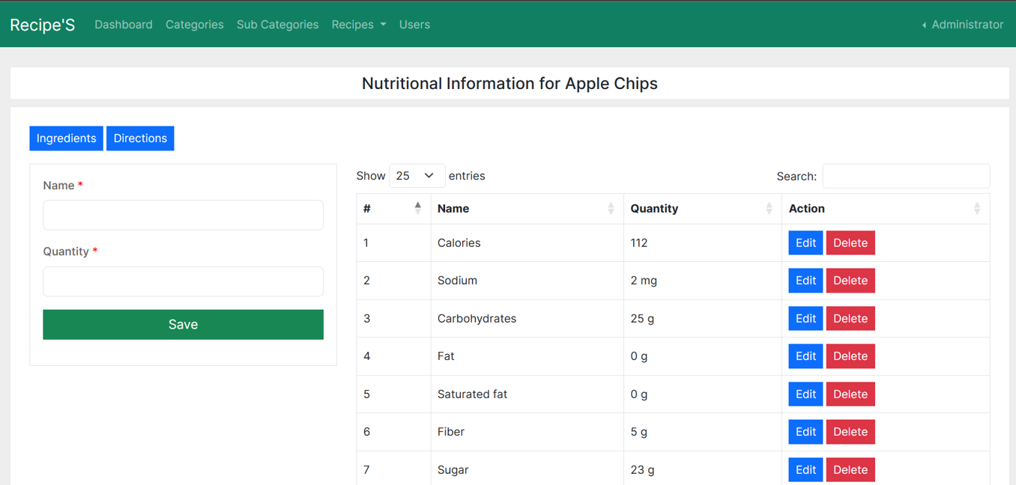

**Admin View Users Page**

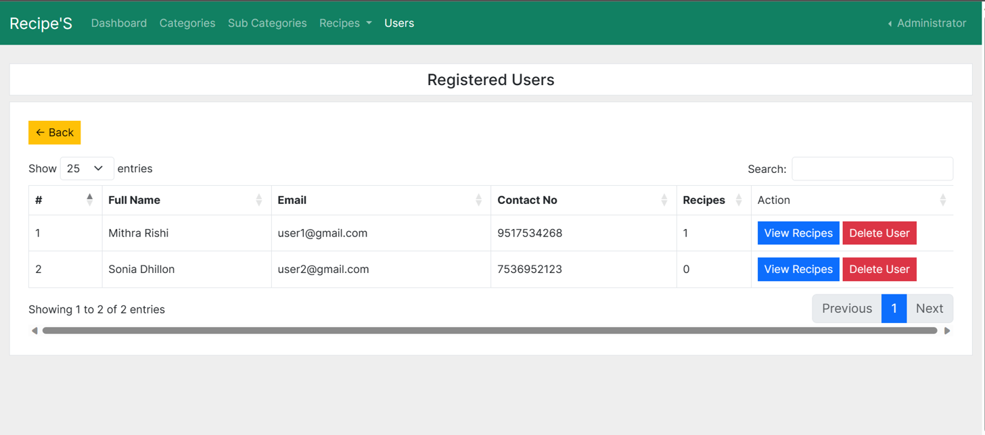

**Users Registration Page**

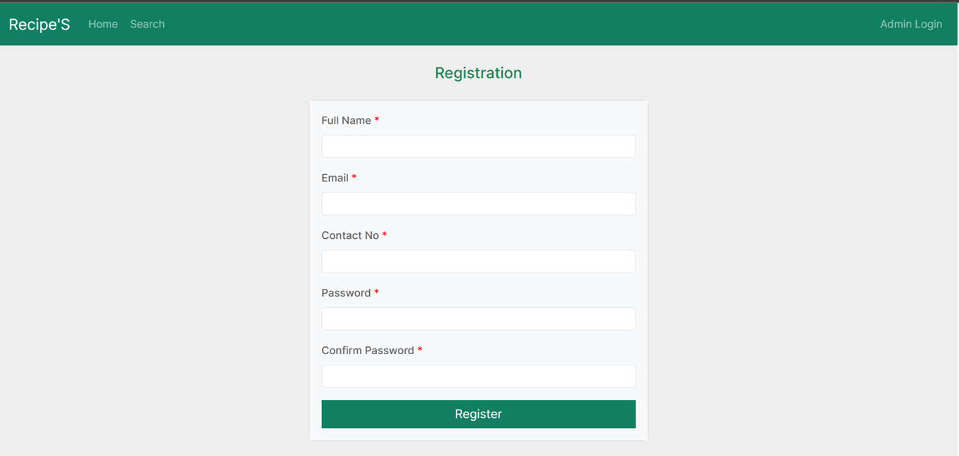

**User Added Recipes Page**

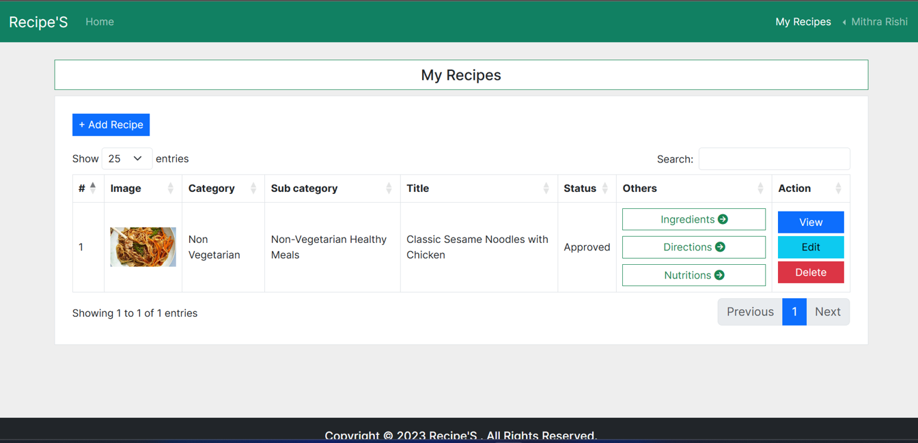

**User Profile Page**

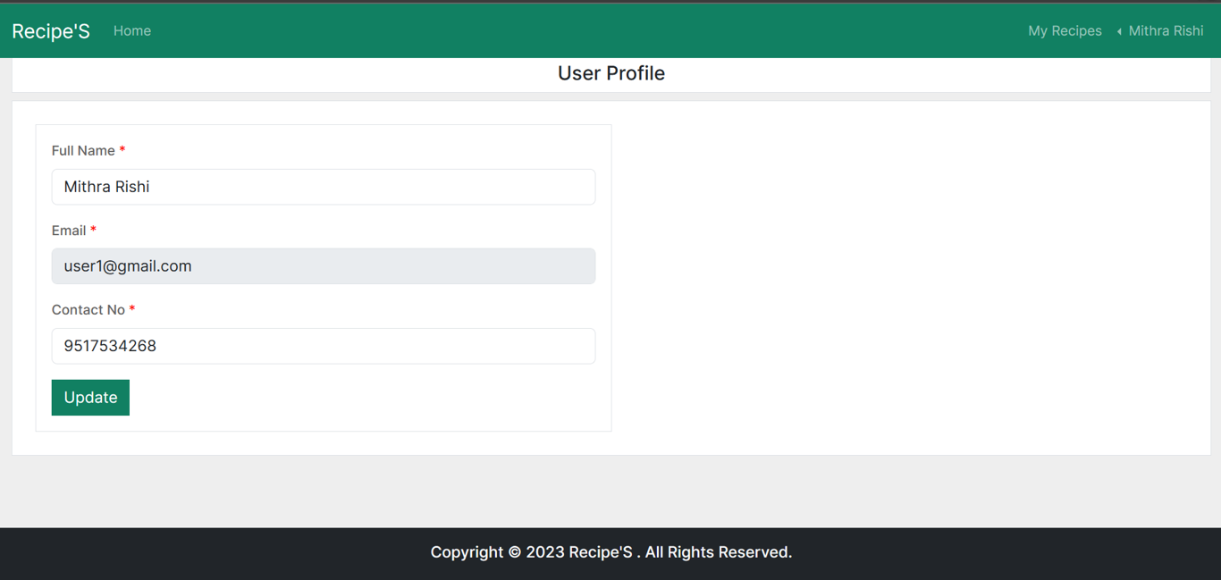

**User Password Change Page**

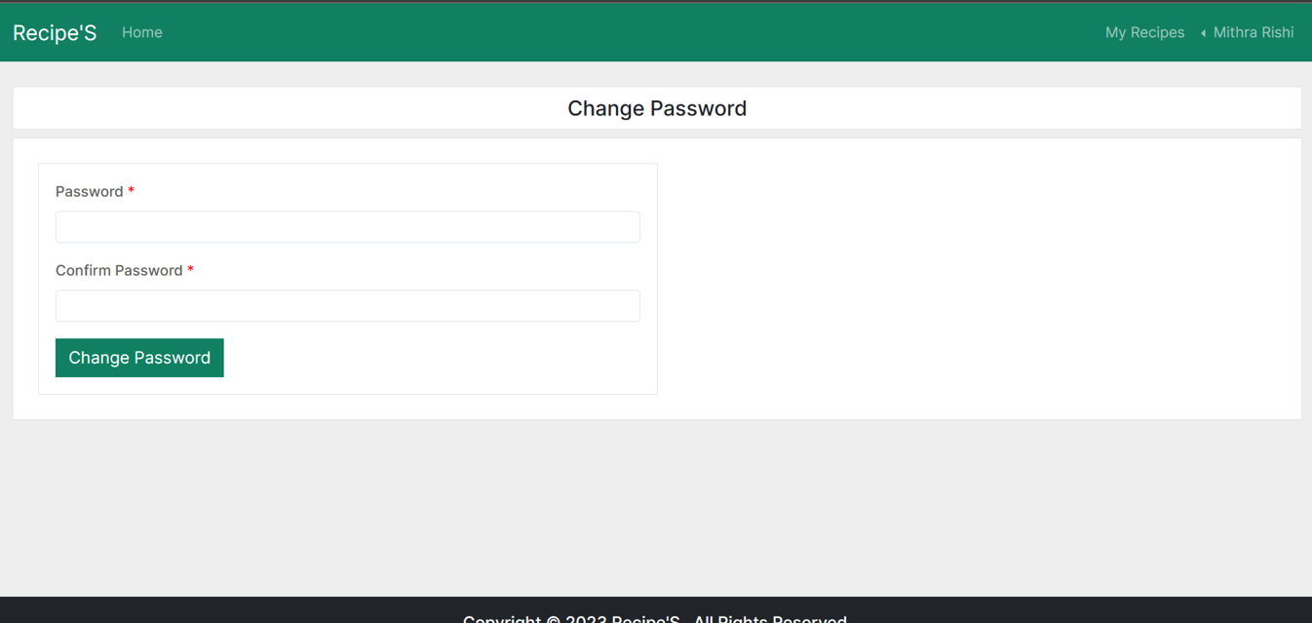

# Source Codes

* 1. **app.py:** execution begins from this file.
  2. **db.py:** MongoDB connections and collections information are defined in this file.
  3. **others.py:** additional functionalities are defined in this file.
  4. **categories.html:** form to add, edit and delete categories.
  5. **change-password.html:** form to reset password.
  6. **directions.html:** form to add, edit and delete directions.
  7. **home.html:** form to home page.
  8. **ingredients.html:** form to add, edit and delete ingredients.
  9. **login.html:** form for admin login.
  10. **nutritions.html:** form to add, edit and delete nutrition information.
  11. **recipe-save.html:** form to save recipe.
  12. **recipe-view.html:** form to view recipe.
  13. **recipes.html:** form to add, edit and delete recipes.
  14. **rejected-recipes.html:** form to view and approve rejected recipes.
  15. **sub-categories.html:** form to add, edit and delete sub-categories.
  16. **user-recipes.html:** form to view, approve and reject user-recipes.
  17. **users.html:** form to view and delete users.
  18. **change-password.html:** form to reset password for users.
  19. **directions.html:** form to add, edit and delete directions for users.
  20. **home.html:** form to home page for users.
  21. **ingredients.html:** form to add, edit and delete ingredients for users.
  22. **login.html:** form for user login.
  23. **my-recipes.html:** form to add, edit and delete recipesfor users.
  24. **nutritions.html:** form to add, edit and delete nutrition information.
  25. **profile.html:** form to view and update profile for users.
  26. **recipe-save.html:** form to save recipe.
  27. **recipe-view.html:** form to view recipe.
  28. **registration.html:** form for user registration.
  29. **search.html:** form for recipe search for users.
  30. **sub-categories.html:** user view recipes by subcategory.

# NoSQL Commands

*Admin home*

total_recipes_count = db.recipes.count_documents({})

recipes_pending_approval_count = db.recipes.count_documents(

{"status": RecipeStatus.Pending.value})

recipes_approved_count = db.recipes.count_documents(

{"status": RecipeStatus.Approved.value})

recipes_rejected_count = db.recipes.count_documents(

{"status": RecipeStatus.Rejected.value})

registered_users = db.users.count_documents({})

*Admin categories*

categories = db.categories.find({"is_active": True})

*Admin subcategories*

sub_categories = db.sub_categories.find({"category_id":category_id})

*Admin recipes*

recipes = db.recipes.aggregate([

{"$match": {"inserted_by": ObjectId(admin_id), "is_active": True}},

{

"$lookup": {

"from": db.categories.name,

"localField": "category_id",

"foreignField": "_id",

"as": "category"

}

},

{

"$lookup": {

"from": db.sub_categories.name,

"localField": "sub_category_id",

"foreignField": "_id",

"as": "sub_category"

}

}

])

*User login*

user = db.users.find_one(values)

if user:

start_session(user)

session["is_user"] = True

return redirect(url_for("index"))

else:

error_msg = "Invalid Login Credentials"

return render_template("/login.html", error_msg=error_msg)

*User recipes*

recipes = db.recipes.aggregate([

{"$match": {"inserted_by": ObjectId(user_id), "is_active": True}},

{

"$lookup": {

"from": db.categories.name,

"localField": "category_id",

"foreignField": "_id",

"as": "category"

}

},

{

"$lookup": {

"from": db.sub_categories.name,

"localField": "sub_category_id",

"foreignField": "_id",

"as": "sub_category"

}

}

])